Nike Air Zoom Pegasus 35 Premium

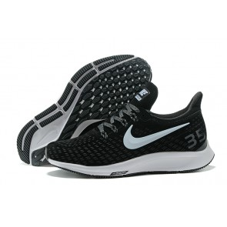

Product code: 1036

The Nike Air Zoom Pegasus 35 Premium is built for runners at every level, whether you're a seasoned veteran or just starting out. It features a breathable mesh upper with an out-turned collar for Achilles comfort. Down below, the cushioning combines full-length Zoom Air and a soft foam that's been tuned for female runners.

# NIKE AIR VAPORMAX FLYKNIT MOC 2

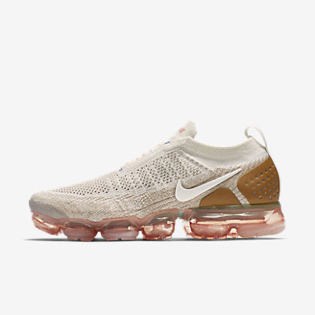

Product code: 1037

With a sleeker take on the original design, the Nike Air VaporMax Flyknit Moc 2 Running Shoe delivers a lightweight, bouncy ride. An elastic gore strap replaces the laces and helps enhance the snug fit. The revolutionary cushioning creates a gravity-defying sensation directly underfoot.

# NIKE EPIC REACT FLYKNIT

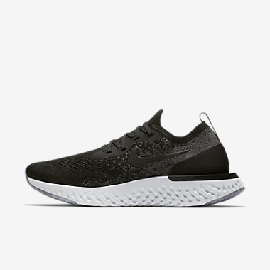

Product code: 1038

The Nike Epic React Flyknit Women's Running Shoe provides crazy comfort that lasts as long as you can run. Its Nike React foam cushioning is responsive yet lightweight, durable yet soft. This attraction of opposites creates a sensation that not only enhances the feeling of moving forwards, but makes running feel fun, too.

# Nike LunarEpic Low Flyknit 2

# 

Product code: 1039

# The Nike LunarEpic Low Flyknit 2 Women's Running Shoe improves on its predecessor with an updated slip-on design for a snug, seamless fit. The same luxurious cushioning and targeted support remain to help you tackle your longest distances.

# Nike Flex 2017 RN

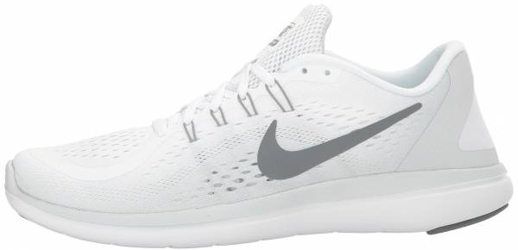

Product code: 1040

The Nike Flex 2017 RN Women's Running Shoe helps keep you light on your feet from start to finish with an engineered mesh upper and lightweight, flexible outsole.